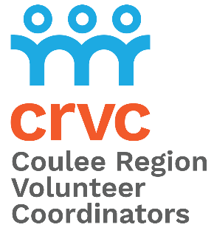
Registration Form

When: Wednesday, April 17, 2024
Where: Cargill Room at the Waterfront
332 Front Street South, La Crosse, WI 54601
Doors open at 7:45 am, Program starts at 8:30 am
Parking: Feel free to park in the Riverside Municipal Parking Ramp

Organization ___________________________________________________________________
Address _______________________________________________________________________
City, State, Zip Code _____________________________________________________________
Contact Person ______________________________ Title ______________________________
Phone ____________________________ Email _______________________________________
Individuals attending breakfast Volunteer Staff
1 ________________________________________________________ __________ _________
2 ________________________________________________________ __________ _________
3 ________________________________________________________ __________ _________
4 ________________________________________________________ __________ _________
5 ________________________________________________________ __________ _________
6 ________________________________________________________ __________ _________
7 ________________________________________________________ __________ _________
8 ________________________________________________________ __________ _________
Number of attendees _____________ at $10 per person = $ _______________
**If you have 8 people in attendance, we will reserve a table for you labeled with your
organization’s name, and a limit of two tables per organization, please. Tables will not be
reserved for groups of less than 8 people.
Reserve table: Y / N

Special dietary requests (Gluten Free/Diabetic) ____________________________________

Registration deadline: Wednesday, March 15, 2024
Note: Volunteer Coordinators who have registered their guests/volunteers will be sent an email before the
breakfast, letting them know their table number, and requesting they come early to help their volunteers with
signing up for door prizes, locating tables, etc.

Please print and mail the completed registration form with your payment, we are unable to accept debit or credit
cards. Checks can be made out to CRVC and mailed to 2920 East Ave South, Suite 104, La Crosse, WI 54601

26th Annual Coulee Region Volunteer Coordinators
Recognition Breakfast

When: Wednesday, April 17, 2024
Where: Cargill Room at the Waterfront
332 Front Street, La Crosse, WI 54601
Doors open at 7:45 am, Program starts at 8:30 am

Guest speaker:
Riverfest Commodore Bill LaRue

Cost: $10 *includes breakfast
Payments are requested before the event by check

Parking: Feel free to park in the Riverside Municipal Parking Ramp

The purpose of the breakfast is to acknowledge the volunteers throughout the Coulee
Region that makes our community a great place to live. Without the commitment,
energy, and loyal support these individuals donate throughout the year, many local
non-profit programs would not be able to exist. Join us at The Waterfront along the
beautiful Mississippi River, and plan to bring your exceptional volunteers for a morning
that celebrates and recognizes their service.

To attend the Breakfast with your volunteers please fill out the registration form and
send the form and your payment to CRVC, 2920 East Ave South, Suite 104, La Crosse, WI 54601. Payments are requested before the event by check.

We hope you can join us!

If you have any questions, please contact Jane Schwartzhoff at jane@neighborsinacton.net or call 507-895-8123.

To learn more about CRVC, please visit couleeregionvolunteer.org

Breakfast Registration Deadline: Wednesday, March 15, 2024

